# Cost Insights SAC Application Naming Convention

Draft

1. Widget names

Each object name should consist of 3 elements

X_Y_Z

**Segment X**

3-4 characters represent object type:

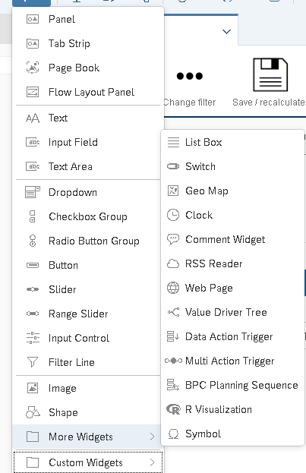

|  |  |
| --- | --- |
| **Code X** | **Object type** |
| BTN | Button |
| PAN | Panel |
| TXT | Text |
| CHRT | Chart |
| POP | Popup |
| TAB | Table |
| TABS | Tabstrip |
| PGBK | Page book |
| FLP | Flow Layout Panel |
| INPF | Input Field |
| TXTA | Text Area |
| DRD | Dropdown |
| CKGR | Checkbox group |
| RDBG | Radio button group |
| SLD | Slider |
| RSLD | Range slider |
| INPC | Input control |
| FILL | Filter line |
| IMG | Image |
| SHP | Shape |
| LBOX | List box |
| SWCH | Switch |
| GEO | Geo map |
| CLK | Clock |
| COMM | Comment widget |
| RSS | Rss |
| WEBP | Web page |
| VDT | Value Driver tree |
| DAT | Data Action Trigger |
| MAT | Multi action trigger |
| PSEC | BPC planning sequence |
| RVIZ | R visualiztion |
| SYMB | Symbol |
|  |  |

**Segment Y**

Indicates area or panel that widget is used on.

Number characters is not restricted-just keep it informative.

**Segment Z**

Indicates purpose/function of a widgets

Examples:

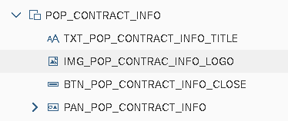

Popup widget name:POP_CONTRACT_INFO

All widgets that belong to this widget contain POP_CONTRACT_INFO in segment Y.

1. Variables

Each global variable starts with VAR_

Variables that can be passed via url start with EXVAR_

1. Scripting objects

All functions start with FUN_